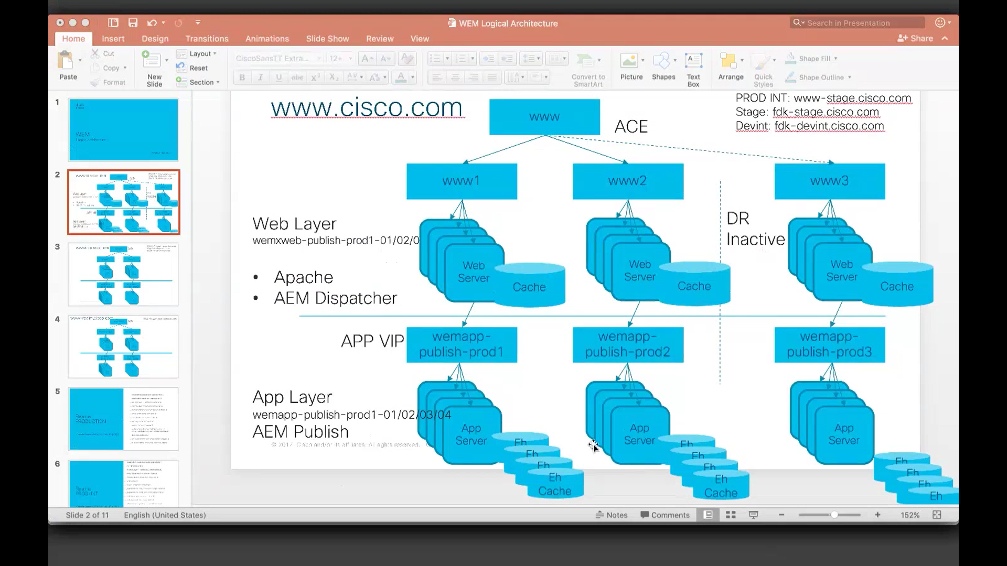

Only these requests come to WEM, the left side are the requests served by legacy servers.

Only WEM takes care of content by AEM

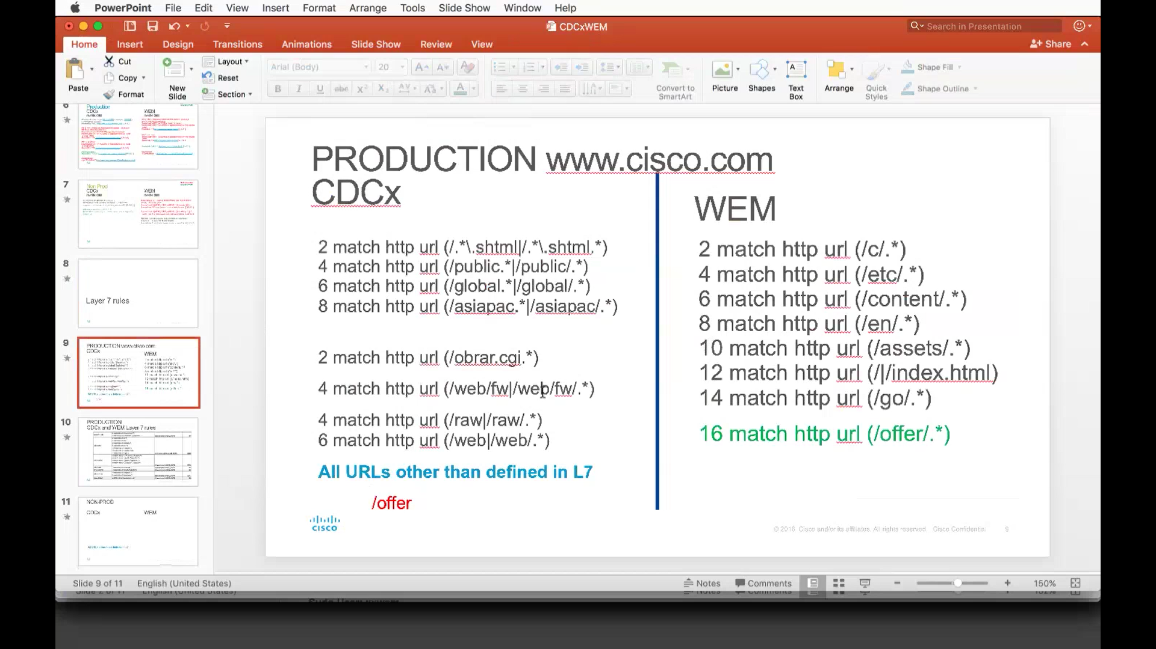

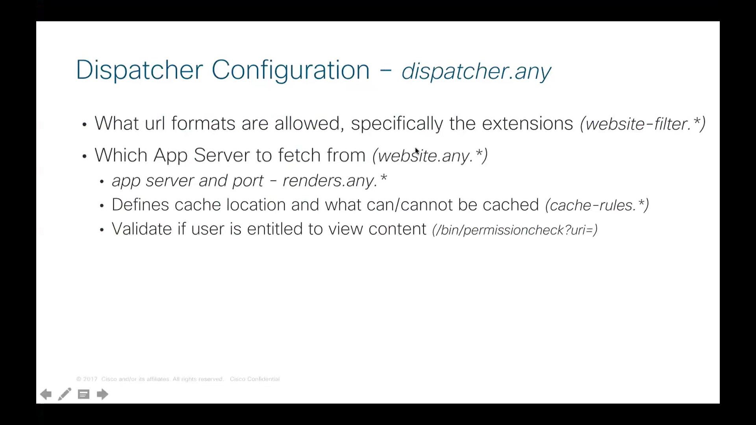

# ReWrite URL

The url address remains intact in the browser but the content gets rendered from somewhere else depending on the user, location and this is controlled by the rules we place in custom config rules

Eg: [www.cisco.com](http://www.cisco.com) loads home page /c/en/us/index.html

We just hit the host without url and we get served by /c/en/us/index.html

Pros:

1. User has no idea regarding what is the target location
2. Short url
3. leveraging rewrite urls we can take the logged in user to various locations and render the content which might differ from user to user.

# Redirect URL

URL in the browser changes as it renders content from different location

301 – moved permanently to another

302 – temporary

# Rewrite Module (Apache)

Apache has many modules, each taking care of specific functionality. Rewrite module takes care of both rewriting and redirecting urls.

**RewriteCond –** this is the condition which has to be checked if it returns true of false

**RewriteRule –** this takes care of rewriting the url, if **RewriteCond** returns true.

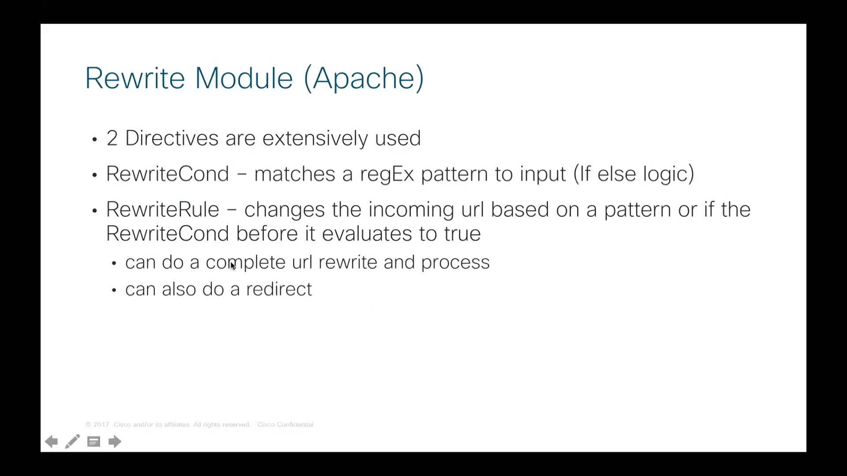

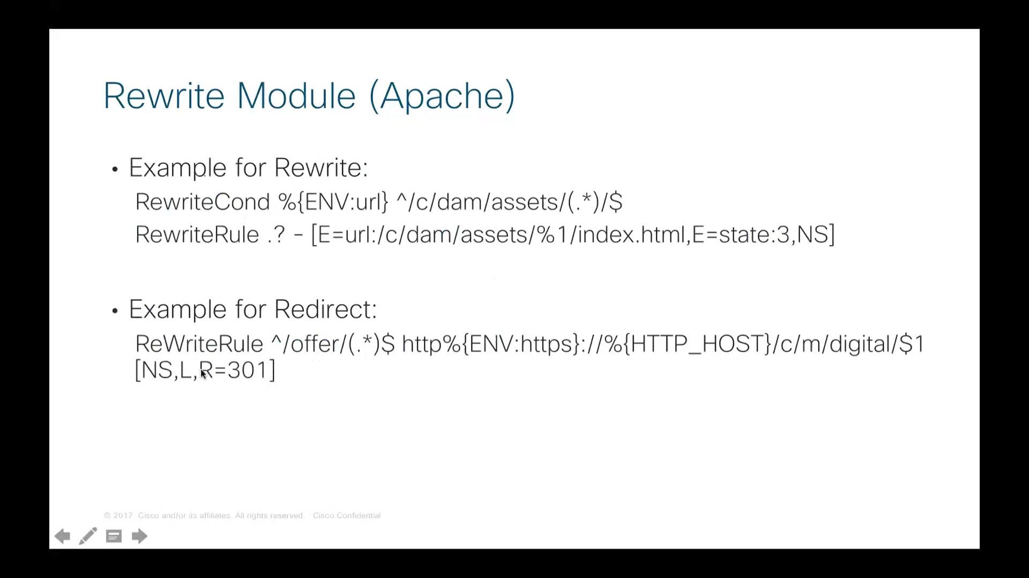

Condition has to be true only then the rule will be applied

This rule itself has condition included in it

From above image its clear that , with **redirect –** we change the url to a different

More information on the regex used in rewrite rules is explained in Video 2 @ **37 min**

Back referencing some thing in **rewriteRule** is done by **$**

Back referencing some thing in **rewriteCond** is done by **%**

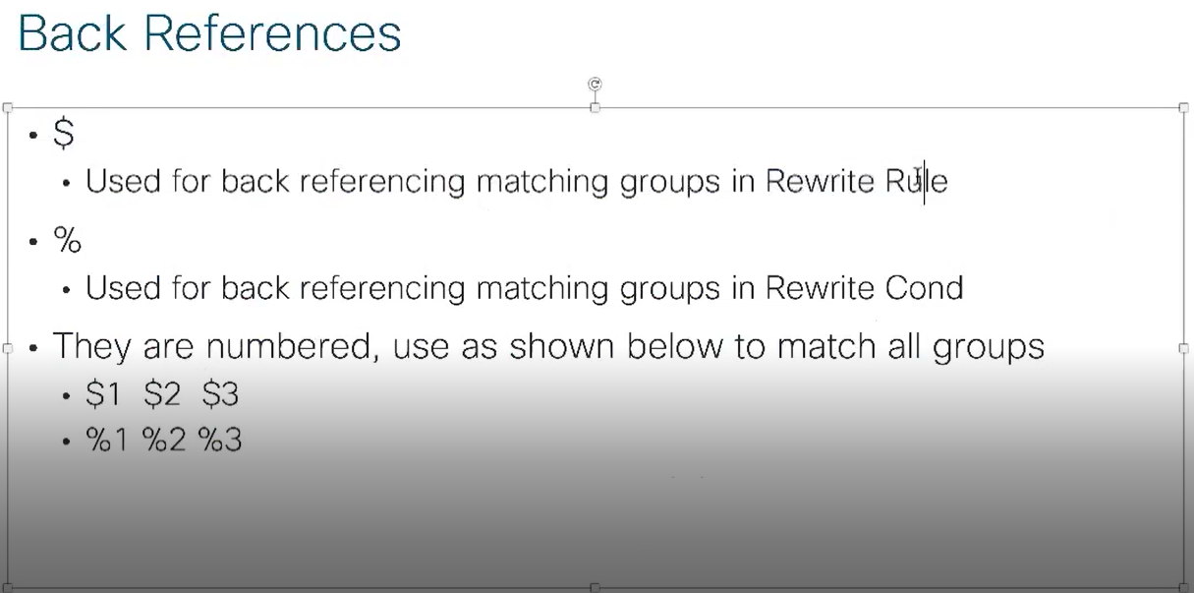

Custom.conf is included at the end of apache web server rules

# Flow

Apache *httpd.conf >>>>>*

Code walk through in **custom.conf.template** at video 3 @ 14:00 min

# DBM

Database Mapping file. It is similar to HashMap in java. Holds key, value pair.

If the input url matches with any of the keys , the corresponding value set is used to rewrite urls

DBM is nothing but a .txt file in which *key* & *value*  are separated by a space

The .txt file is compiled to return a .**dbm** file

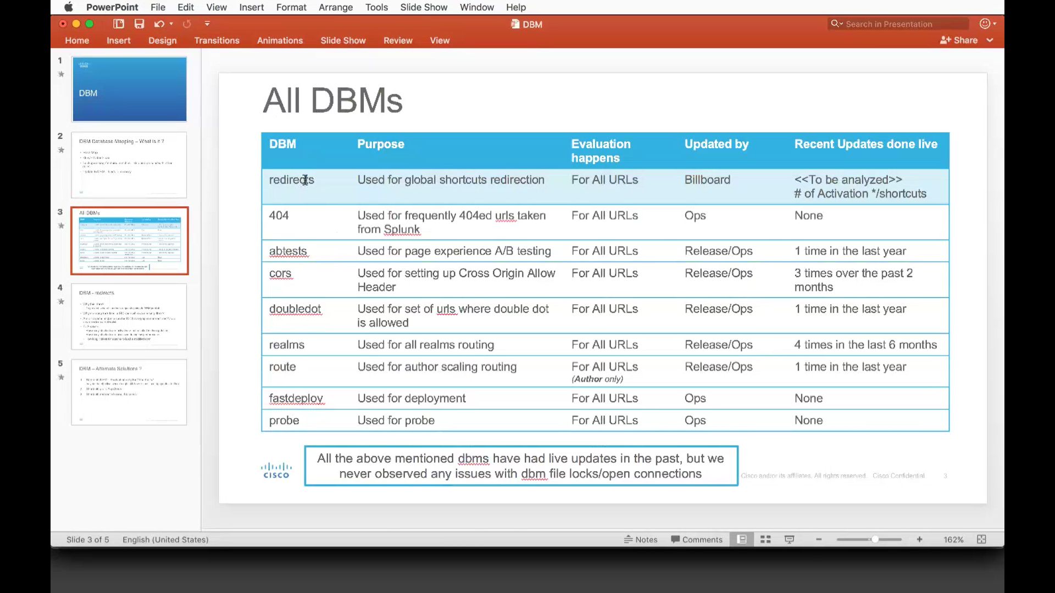

# Dispatcher

In publish, we deny everything and then allow selectively

In author, everything is allowed

The rules in dispatcher are applied in top to down fashion

i.e., some rule allowes for ‘/a/b’ at line # 1

some other rule denies for ‘/a/b’ at line #30

line # 30 takes precedence